Lecture 12: Specification Sheet

Portfolio, Team & Testimonial Section using HTML & CSS

1. Lecture Title
Responsive Portfolio, Team & Testimonial Section Design

2. Lecture Objective
After completing this lecture, students will be able to:
- Create responsive Portfolio section
- Design Team member cards
- Build Testimonial section
- Use CSS Grid Layout
- Apply hover effects using CSS
- Create responsive card layouts
- Use Font Awesome icons
- Apply box-shadow and border-radius
- Design professional website sections
- Make layouts mobile responsive

3. Portfolio / Project Section
A Portfolio Section or Project Section is a website area where projects or works are displayed.
It shows:
- Previous projects
- Website designs
- Apps
- Business works
- Creative works
- Client projects

Purpose of Portfolio Section
- Show skills and experience
- Attract clients or employers
- Present completed works professionally
- Build trust and credibility

Common Contents
- Project Image
- Project Title
- Short Description
- Project Link/Button

Team Section
A Team Section shows the people working in a company or organization.
It introduces:
- Team members
- Developers
- Designers
- Managers
- Staff members

Purpose of Team Section
- Build trust
- Show professionalism
- Introduce company members
- Make website more human-friendly

Common Contents
- Member Photo
- Name
- Designation
- Social Media Links

Testimonial Section
A Testimonial Section displays reviews or feedback from clients/customers.
It contains:
- Client opinion
- User feedback
- Customer review
- Satisfaction comments

Purpose of Testimonial Section
- Increase trust
- Show customer satisfaction
- Improve business credibility
- Encourage new clients

Common Contents
- Client Review
- Client Name
- Profession/Company
- Client Photo (optional)
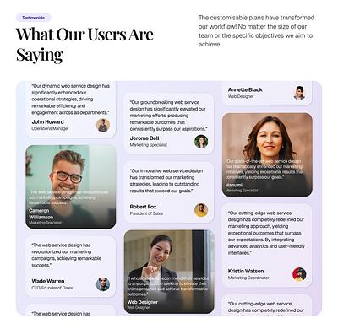
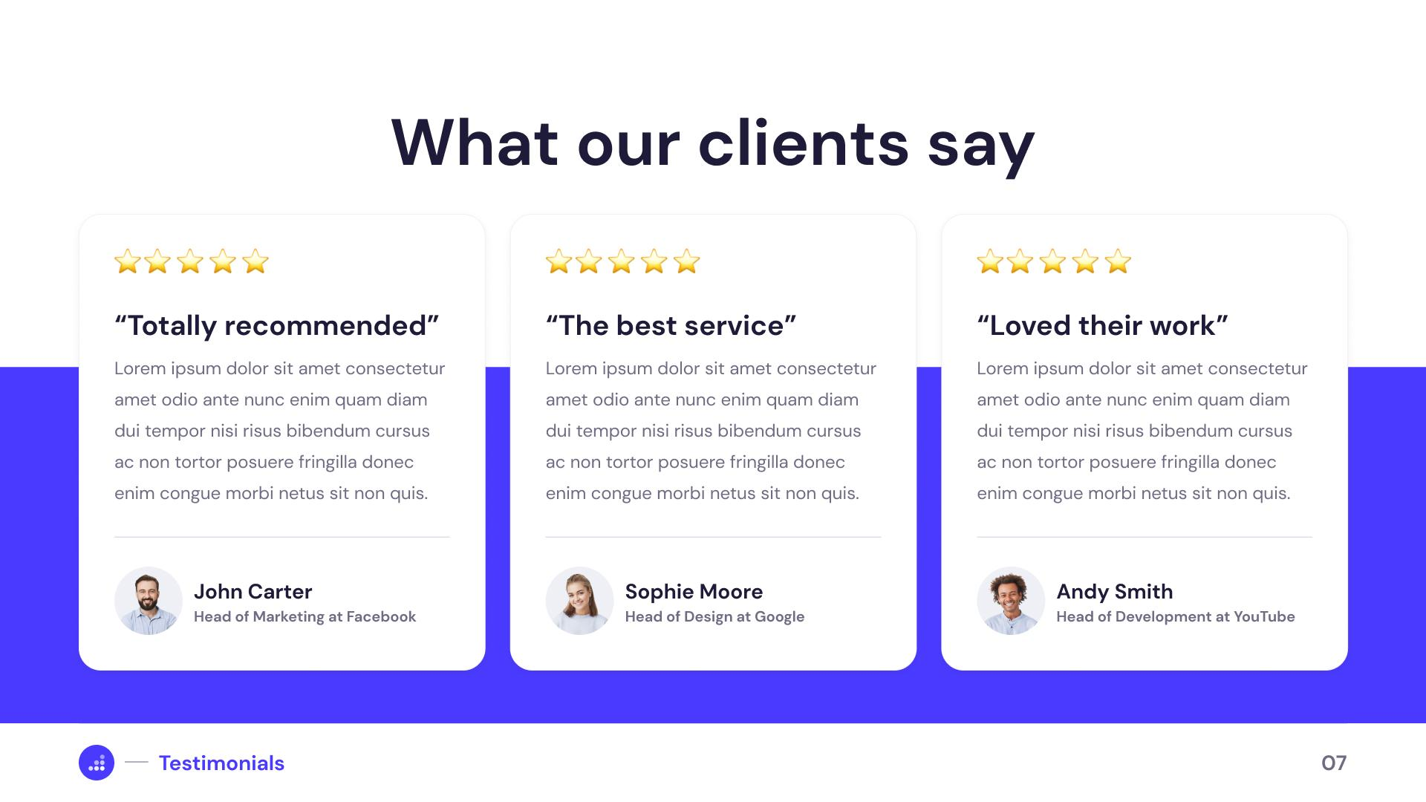
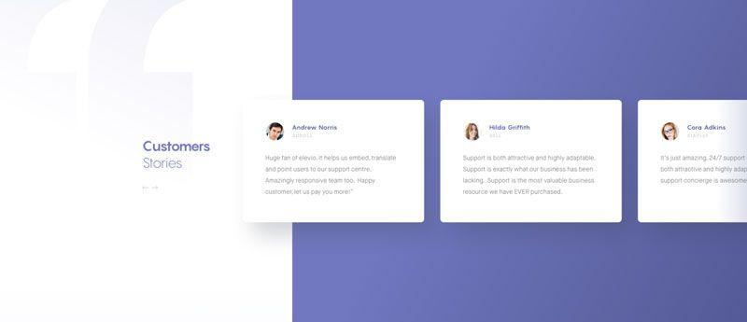

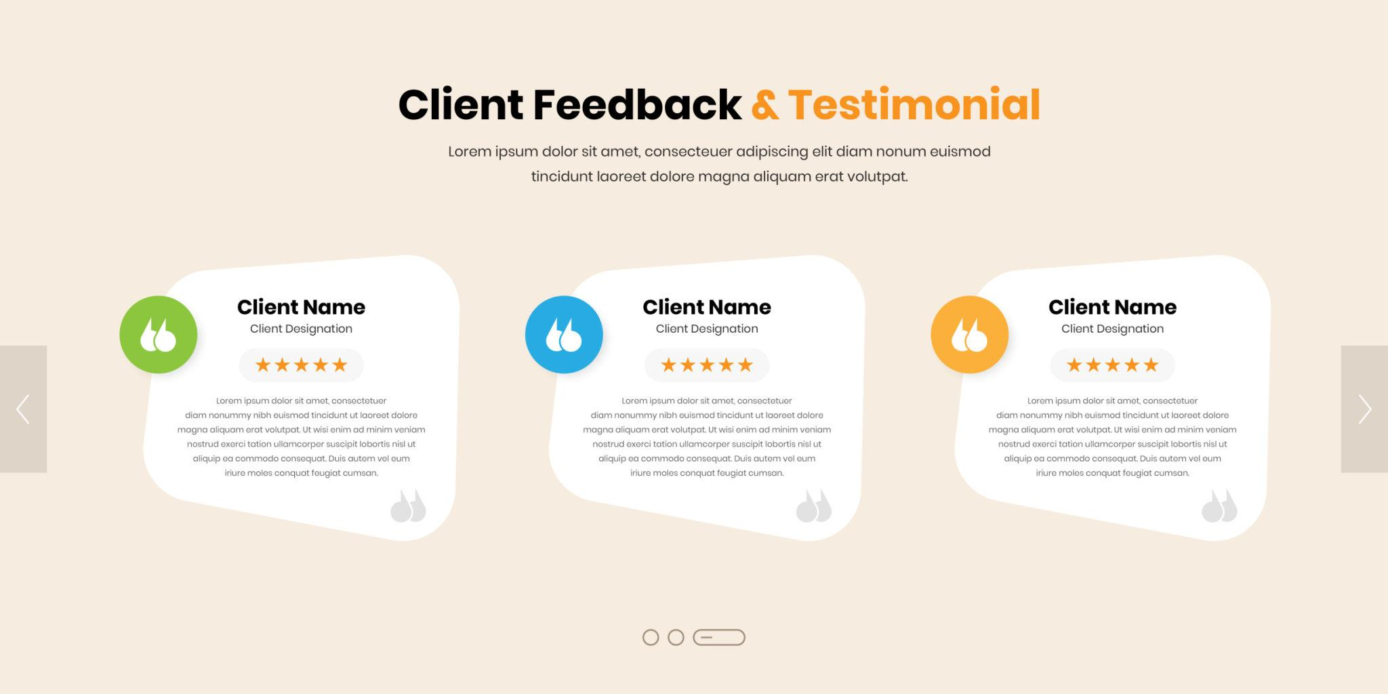

3.1 Technologies Used
- HTML5
- CSS3
- CSS Grid
- Responsive Design
- Font Awesome Icons

4. HTML Structure Used

Portfolio Section

Main Elements
- <section>
- <div>
- <img>
- <h2>
- <h3>
- <p>

Main Classes
- .portfolio
- .portfolio-wrapper
- .portfolio-card
- .portfolio-content

Team Section

Main Elements
- <section>
- <img>
- <h3>
- <p>
- <a>
- <i>

Main Classes
- .team
- .team-wrapper
- .team-card
- .team-social

Testimonial Section

Main Elements
- <section>
- <div>
- <h2>
- <h3>
- <p>
- <span>

Main Classes
- .testimonial
- .testimonial-wrapper
- .testimonial-card

5. CSS Properties Used

Layout Properties
- display:grid
- grid-template-columns
- gap
- padding
- margin

Card Design Properties
- background
- border-radius
- box-shadow
- overflow:hidden

Typography Properties
- font-style
- text-align
- margin-bottom

Image Properties
- width
- height
- object-fit
- border-radius

Hover Effects
- transition
- transform:translateY()

Responsive Design
- @media
- max-width
- repeat(auto-fit,minmax())

6. Portfolio Section Features
- Responsive project grid layout
- Project image display
- Project title and description
- Hover animation effect
- Modern card design
- Flexible responsive columns

7. Team Section Features
- Team member profile cards
- Circular profile images
- Social media icons
- Hover animation
- Responsive grid system
- Professional team layout

8. Testimonial Section Features
- Client review cards
- Italic testimonial text
- Client information display
- Responsive card design
- Professional shadow effect

9. Responsive Features

Desktop View
- Multiple columns
- Grid-based layout
- Equal spacing between cards

Mobile View
- Single column layout
- Full width cards
- Better readability on small devices

10. Important CSS Concepts

CSS Grid
display:grid;
grid-template-columns:repeat(auto-fit,minmax(300px,1fr));

Purpose
- Creates responsive columns automatically
- Adjusts layout based on screen size

Hover Effect
transform:translateY(-10px);

Purpose
- Moves card upward on hover
- Creates interactive animation

Box Shadow
box-shadow:0 5px 15px rgba(0,0,0,0.1);

Purpose
- Adds soft shadow around cards
- Creates modern depth effect

Responsive Media Query
@media(max-width:768px)

Purpose
- Applies styles for mobile devices
- Makes layout responsive

11. Learning Outcomes
Students will learn:
- Responsive section design
- Professional card layout creation
- Grid layout system
- Responsive image handling
- CSS hover animation
- Modern UI section structure
- Team profile layout design
- Testimonial card design

12. Practical Applications
This design can be used for:
- Business websites
- Portfolio websites
- Agency websites
- Corporate websites
- Freelancer portfolios
- Educational websites

13. Assignment Task
Create:
- 6 portfolio cards
- 4 team member cards
- 5 testimonial cards
- Add custom hover effects
- Make fully responsive layout

14. Final Project Output
Students will create:
- Modern Portfolio Section
- Professional Team Section
- Responsive Testimonial Section
- Fully Mobile-Friendly Website Layout

